L051/CL1118 COMBIANTION SLIDE BOLT
INSTRUCTION
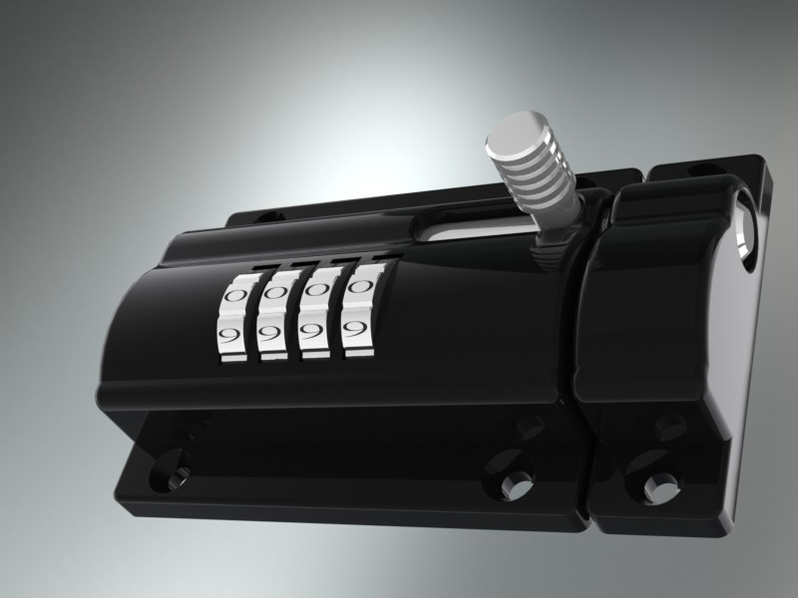
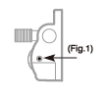
Feature:
The Combination slide bolt offers keyless convenience in the form of a traditional, beefy barrel bolt. It is very popular with sheds, gates, garden fence and any application where by a barrel bolt or padlock and hasp would be used
Usage:
Step. 1. The combination slide bolt is factory pre-set 0-0-0-0.
Step. 2. Set the dials to the correct code, and use a sharp tool to insert it in the rest hole which is located on the right hand side of main body(Fig. 1). Push the tool and hold it, now you can change your desired code and please write it down and keep in a safe place in order if forgetting the code.
Step. 3. After you changed the code, release the tool and check the new slide bolt with your new combination.

US, Taiwan, China patented
